Project Design Phase-II
Data Flow Diagrams and User Stories

Date | 07 November 2025
Team ID | NM2025TMID09096
Project Name | Optimizing User, Group, and Role Management with Access Control and  Workflows
Maximum Marks | 4 Marks

Data Flow Diagrams:
A Data Flow Diagram (DFD) is a visual tool used to represent how information moves within a system. A clear and structured DFD effectively illustrates the overall system requirements by showing how data enters, exits, and flows through various components, as well as how it is transformed and stored. In the project “Optimizing User, Group, and Role Management with
Access Control and Workflows,” Data Flow Diagrams (DFDs) demonstrate how user, group, and role data are processed across different stages of the system.
The DFD visualizes the interactions among the admin, system, and database components to ensure validation of actions and maintenance of data consistency.
Example:
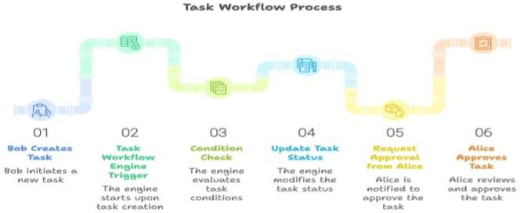

User Stories:
User stories describe the needs and expectations of various users in simple, goal-oriented language. In this project, they define how the system should efficiently manage user, group, and role configurations while
maintaining workflow automation and access control integrity.

User Type | Functional Requirement (Epic) | User Story Number | User Story / Task | Acceptance Criteria | Priority / Release
Administrator | User Management | USN-1 | As an admin, I want to create, modify, or  delete users while ensuring roles and groups are updated automatically. | The system should  validate linked entities before any modification. | High / Sprint-1
System | Access Validation | USN-2 | As a system, I must  automatically validate group and role dependencies before updating access  information. | No user or group should have  conflicting access mappings. | High / Sprint-1
Manager | Workflow Approval | USN-3 | As a manager, I want to review and approve workflow requests  related to  group and role assignments. | The system should generate  notifications for pending approvals. | Medium / Sprint-2

